Redistricting Georgia
Draw your own electoral districts for Georgia, and be sure to consider population, demographics, and other geographic factors. Write a brief explanation on what resources you used to determine the boundaries of your district.
Optional: Have the class vote on which map to approve.
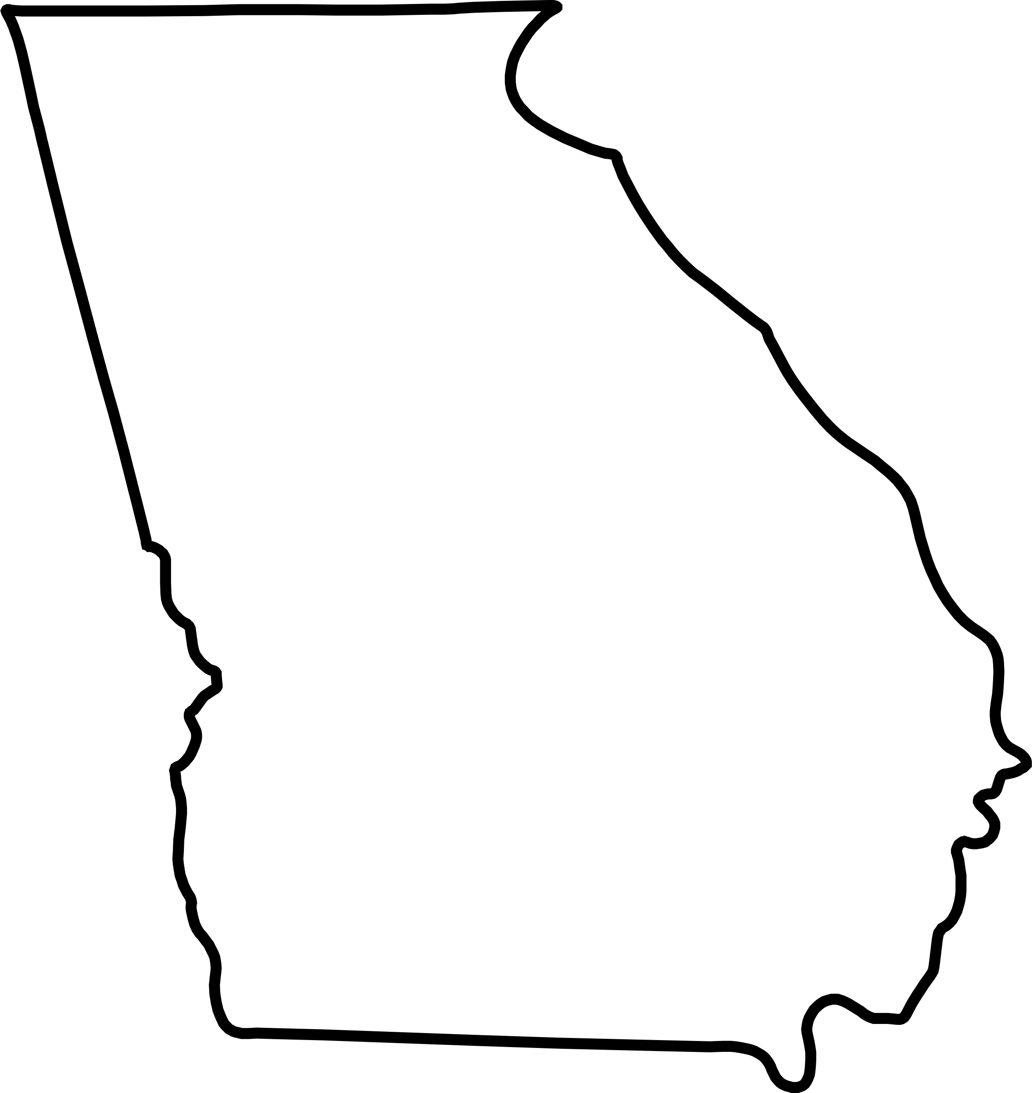
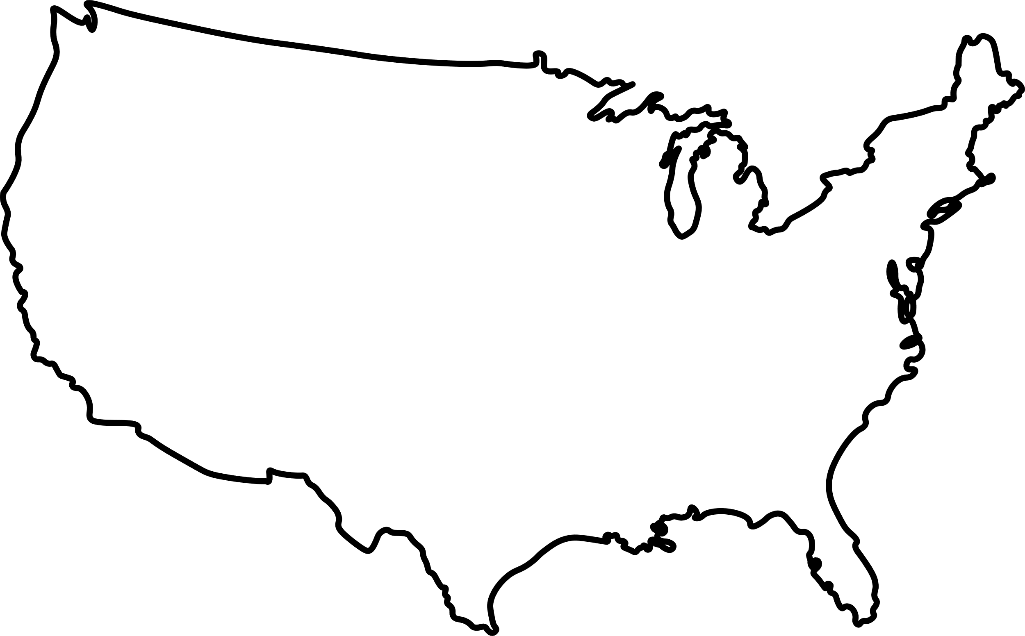
State v. Federal
The U.S. constitution gives some power to state lawmakers and some power to federal lawmakers. From the list below, identify which laws our state legislature can pass and which ones the U.S. Congress can pass. Which violate the state or federal constitution?
Optional: List what type of majority is needed to pass each piece of legislation, and whether or not it requires approval from the governor or president.
- Bill 4051 assigning boundaries to voting districts for the state legislature.
  - State legislature
- Bill 6548 assigning boundaries to voting districts for the U.S. House of Representatives.
  - State legislature.
- Bill 8983 prohibiting people from talking bad about the Atlanta Braves (the state’s baseball team).
  - Unconstitutional
- Bill 3216 establishing a 10% property tax in the state of Georgia.
  - State legislature/local government
- Bill 9816 declaring war on Wisconsin (they know what they did).
  - Unconstitutional
- Bill 3541 establishing a national park in Waynesboro, Georgia.
  - U.S. Congress
- Bill 7953 establishing a state park in Rabun County, Georgia.
  - State legislature
- Bill 7354 establishing a 20% tax on all international imports.
  - U.S. Congress
- Bill 1354 establishing the horseshoe crab as the state crustacean.
  - State legislature
- Bill 7638 amends the state constitution to protect all citizen’s rights to eat ice cream.
  - State legislature

Essay
Why are there limitations on who can run as a state representative or senator? Choose one restriction (age, residency) to argue for or against.
Essay
Why are there limitations on what laws certain legislators can pass? Choose one power currently assigned to the federal government and argue for or against it being a power that the state government can regulate.

